|  |  |  |  |  |  |  |
| --- | --- | --- | --- | --- | --- | --- |
| A1 | A0 | B1 | B0 | A>B | A=B | A<B |
| 0 | 0 | 0 | 0 | 0 | 1 | 0 |
| 0 | 0 | 0 | 1 | 0 | 0 | 1 |
| 0 | 0 | 1 | 0 | 0 | 0 | 1 |
| 0 | 0 | 1 | 1 | 0 | 0 | 1 |
| 0 | 1 | 0 | 0 | 1 | 0 | 0 |
| 0 | 1 | 0 | 1 | 0 | 1 | 0 |
| 0 | 1 | 1 | 0 | 0 | 0 | 1 |
| 0 | 1 | 1 | 1 | 0 | 0 | 1 |
| 1 | 0 | 0 | 0 | 1 | 0 | 0 |
| 1 | 0 | 0 | 1 | 1 | 0 | 0 |
| 1 | 0 | 1 | 0 | 0 | 1 | 0 |
| 1 | 0 | 1 | 1 | 0 | 0 | 1 |
| 1 | 1 | 0 | 0 | 1 | 0 | 0 |
| 1 | 1 | 0 | 1 | 1 | 0 | 0 |
| 1 | 1 | 1 | 0 | 1 | 0 | 0 |
| 1 | 1 | 1 | 1 | 0 | 1 | 0 |

DESIGN A 2BIT COMPARATOR USING COMBINATIONAL CIRCUITS.

1] A<B=A1’B1+A1’A0’B0+A0’B1B0

TURTH TABLE

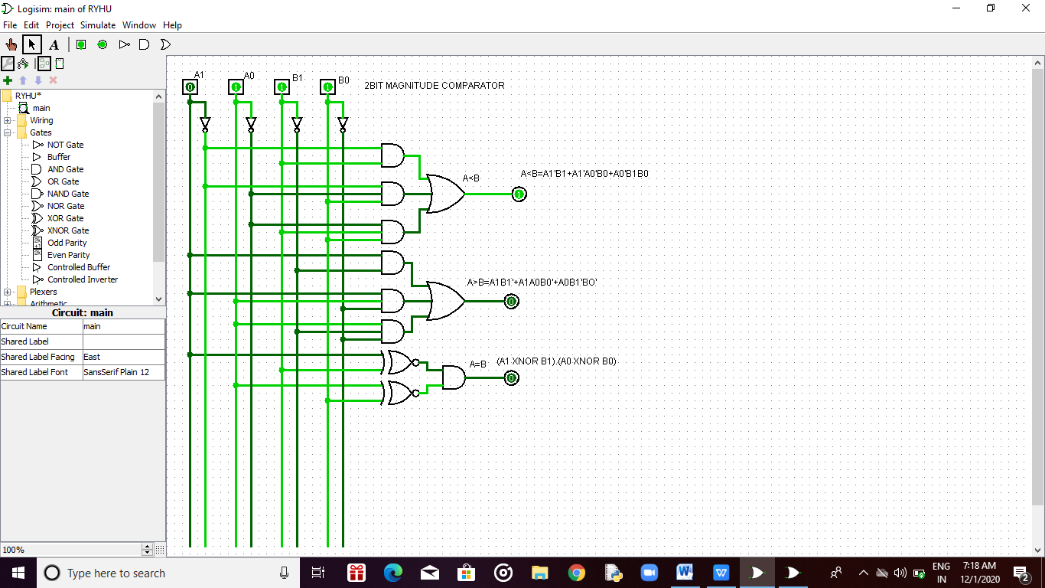

2] A>B=A1B1’+A1A0B0’+A0B1B0’

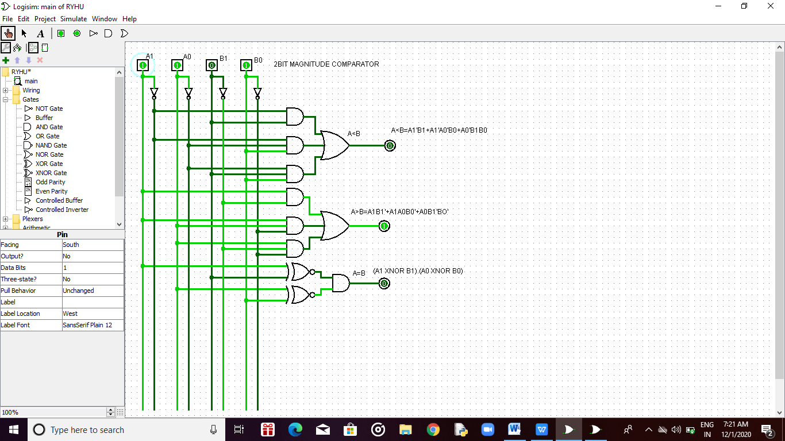

3] A=B

(A1 XNOR B1).(A0 XNOR B0)

